Yoga Retreat with Lisa Walford
ॐ
ॐ
February 15 – 28, 2014
Puri ҉ Calcutta ҉ Varanasi

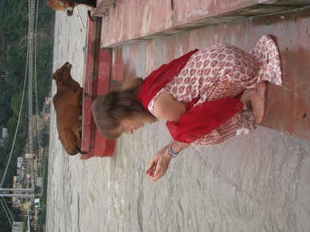
Recharge, renew, and rejuvenate, in two of the most spiritually saturated places on Earth: Puri - one of the four Char Dhams, or sacred pilgrimage destinations in India - and Varanasi - the most ancient of cities, and a pilgrim’s mecca, where the rhythms of life are palpable next to the sacred waters of the Ganges. Magical, colorful, and rich with cultural history, our memories of Puri and Varanasi will last a lifetime.
In Puri
We’ll enjoy daily practice of asana and pranayama with Lisa. We’ll visit the Sri Jagannath Temple in Puri, and the Sun Temple in Konark, where we will enjoy an award-winning Dance and Music festival. Lastly, we’ll take several relaxing rickshaw rides and visit local craft villages.
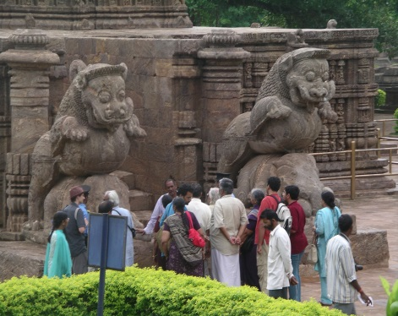
In Calcutta
A visit to the revered Kalighat Temple, dedicated to the Goddess Kali, will drop us into the bustling mix of life that typifies the urgency of seeking spiritual grace amidst the throng of humanity. A glimpse of the Goddess’s eyes is considered a blessing.
In Varanasi
Greeting the sunrise by boat is magical; rambling through the back streets of this city will tease all our senses, and strolling on the riverside ghats with our guide is a photographer’s paradise. We’ll also visit Sarnath, where Buddha gave his first darshan.
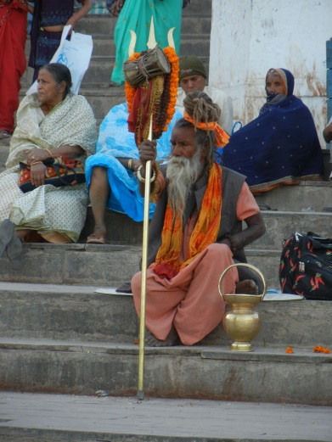
Schedule
Sat Feb 15th leave US » Mon 17th Delhi » Tue 18th Puri » Sat 22nd Calcutta » Sun 23rd Varanasi » Thu 27th Delhi » Fri 28th arrive US
Cost
US $2,999 ($3,299 after February 1st), includes all transportation within India, double-occupancy upscale accommodations (5-star in Puri & Calcutta), and full-time personal tour guide. Single-occupancy may be available. Breakfast and Lunch are included. Please register soon, as we are limited to 15 participants.
All levels are welcome. For more details, or to register, please call/text 310.985.9642, email puri@walford.com, or visit walford.com/puri.
About Lisa
Lisa Walford holds an Intermediate Senior Iyengar Yoga certificate, is on the Board of Iyengar Yoga Therapeutics, and was on the faculty of several national Iyengar Yoga conventions. She writes for Yoga Journal and has co-authored several books on nutrition. She has been teaching for over 30 years. In her rigorous and technically informative classes, Lisa creates an ambiance of internal focus inspiring both beginning and advanced students.

